Assignment 11 14/12/2021

- Given the data
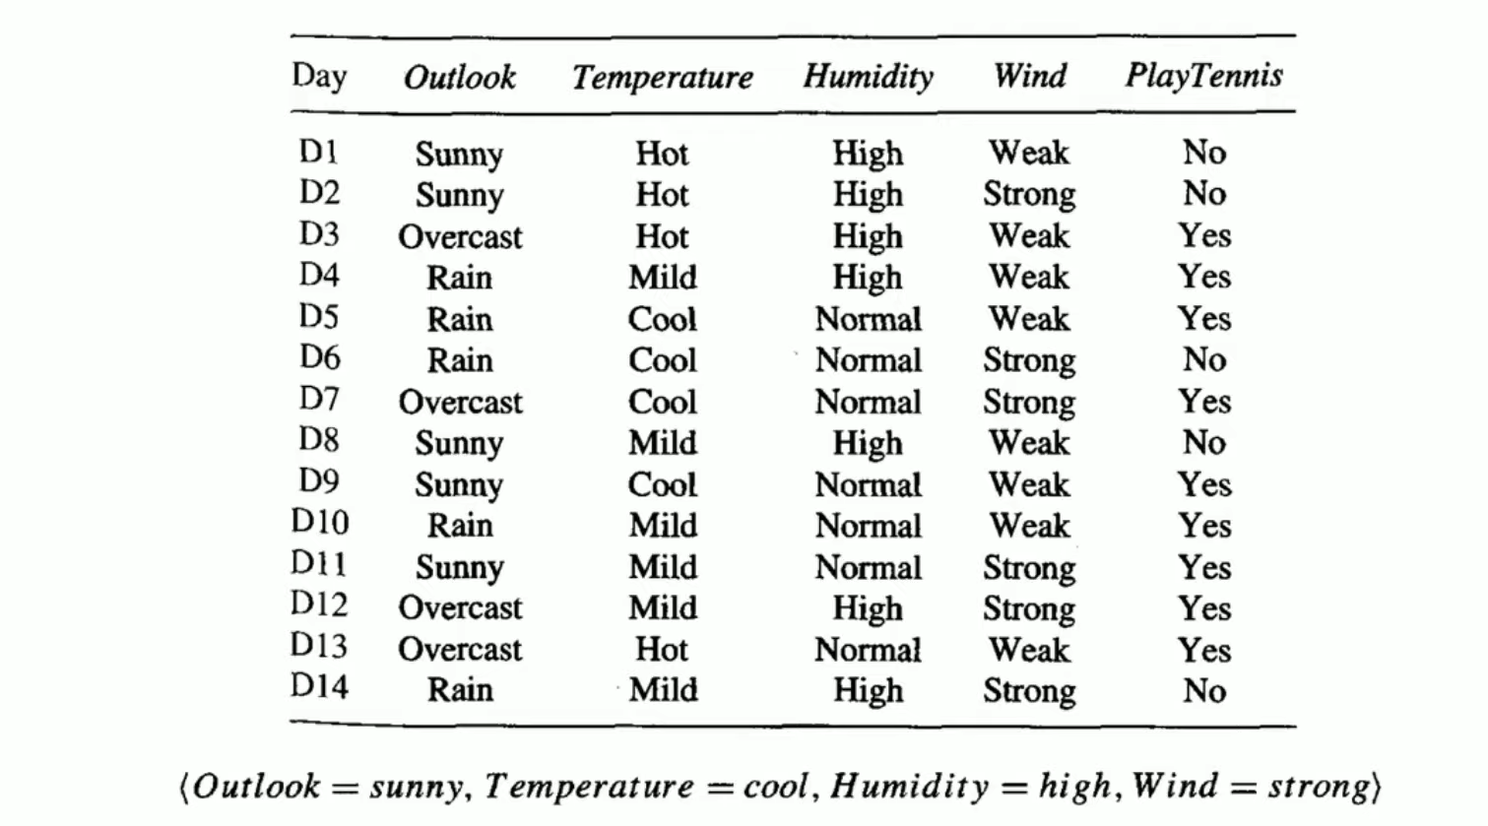
For New Instance given above, find if the game will be played. Use Naïve Bayes

- Given the data
 | Height | Weight
1 | 185 | 72
2 | 170 | 56
3 | 168 | 60
4 | 179 | 68
5 | 182 | 72
6 | 188 | 77
7 | 180 | 71
8 | 180 | 70
9 | 183 | 84
10 | 180 | 88
11 | 180 | 67
12 | 177 | 76

Divide the above given data points into 2 clusters using k-Means clustering.

- Given the data
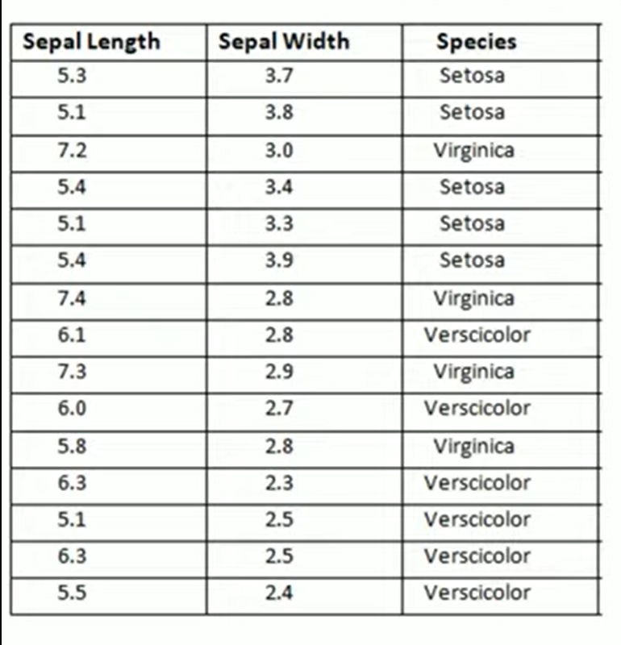
Classify the new instance given below using K Nearest Neighbour..

- Implement Artficial Neural Network for the first output using the below given records and calculate the total loss.
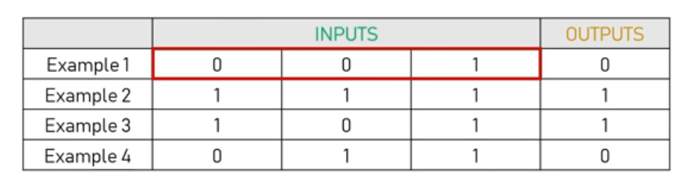
Initialize the weights as w1=0.15, w2=0.20 and w3=0.25
Use sigmoid activation function.

Code:
import numpy as np
def sigmoid(x):
return (1/(1+np.exp(-x)))
trainX=np.array([[0,0,1],
[1,1,1],
[1,0,1],
[0,1,1]])
trainY=np.array([[0,1,1,0]]).T
weights=np.array([0.15,0.20,0.25])
print(weights)
for i in range(1):
input_layer=trainX
output=sigmoid(np.dot(input_layer,weights))
print("Outputs after training")
print(output)

Write the code for calculating the total loss or total error.

